Water Cats Fall Regatta 2024
September 21-22, 2024
Hosted by Water Rats Sailing Club
4 Regatta Road, Toronto, ON M5A 0B7, Canada
SAILING INSTRUCTIONS
1. RULES
1.1. The regatta will be governed by the Rules as defined in The Racing Rules of Sailing.
1.2. In case of conflict between these Sailing Instructions and any other Rule, these Sailing Instructions will prevail.
2. NOTICES TO COMPETITORS & INFORMATION MEETING
2.1. Notices to competitors will be posted on the Water Rats bulletin board inside the Water Rats club house.
2.2. There will be a competitors’ meeting on Saturday, September 21, 2024, at 10:00 am. Other competitors’ meetings may be scheduled as required.
3. CHANGES TO SAILING INSTRUCTIONS
3.1. Any change to the sailing instructions will be posted no less than 1 hour prior to the first scheduled race on the day it will take effect, except that any change to the schedule of races will be posted by the close of protest time (Instruction 15.2) on the day before it will take effect.
4. SIGNALS MADE ASHORE
4.1. Signals made ashore will be displayed on the club's flagpole by the clubhouse.
4.2. When flag AP is displayed ashore, ‘1 minute’ is replaced with ‘not less than 30 mins in race signal AP. This changes Race Signal AP.
5. SCHEDULE OF RACES
5.1. The scheduled race information is given in the table below.
5.2. On the last day of the regatta no race to start after 3:30 pm.
5.3. One extra race per day may be sailed, provided that no class becomes more than one race ahead of schedule and the change is made according to Instruction 3.

Date | Class | First Warning Signal | Max Races per Day
Sat, Sep 21 | All | 11:00 AM | 5 races
Sun, Sep 22 | All | 11:00 AM | 5 races

6. CLASS FLAGS
6.1. Class flag assignments will be as follows:
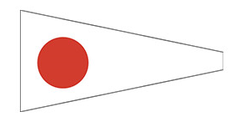
- Code flag “1” – Low Portsmouth
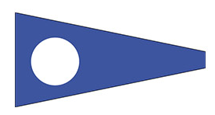
- Code flag “2” – High Portsmouth

7. RACING AREA
7.1. Racing area will be on Lake Ontario, South of the Toronto Islands.
Figure 1: Racing Area
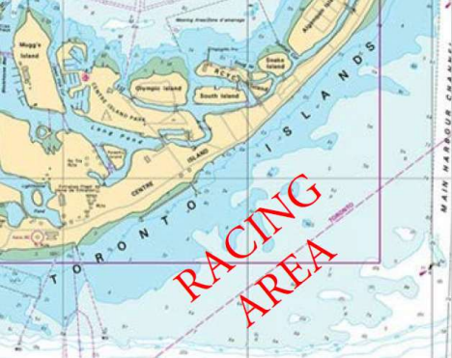

8. THE COURSE
8.1. The upwind/downwind course is illustrated in Appendix A (Pages 6 and 7).
8.2. All marks left to Port.
9. MARKS
9.1. The Weather Mark “1” and Leeward Mark “2” will be inflatable orange tetrahedrons.
9.2. The Start/Finish mark will be a Pin with a red flag.
9.3. If a barging (keep away) buoy is used at the Race Committee signal boat, the buoy and its line shall rank as part of the boat and will be considered an obstruction.
10. THE START
10.1. The starting line will be between an orange flag on the Race Committee signal boat and the windward side of the start/finish mark (a Pin with a red flag).
10.2. Boats whose warning signal has not been made shall avoid the starting area during the starting sequence for other races.
10.3. A boat starting later than four minutes after her starting signal will be scored Did Not Start without a hearing. This changes RRS A4.
10.4. Minimum wind conditions: No race will be started in under 3 knots of wind at all marks of the course as determined by the Race Committee.
10.5. Order of the starts will be announced at the competitors’ meeting and will be posted on the official notice board if different than instruction 6.1. Multiple classes may be started together at the discretion of the Race Committee.
11. CHANGE OF THE NEXT LEG OF THE COURSE
11.1. Course changes may be made in accordance with Rule 33.
11.2. Boats shall pass between the Race Committee boat signaling the change of the next leg and the nearby mark, leaving the mark to port and the Race Committee boat to starboard.
12. THE FINISH
12.1. The finishing line will be between an orange flag on the signal boat and the course side of the start/finish mark (a Pin with a red flag).
13. PENALTY SYSTEM
13.1. Rule 44.1 is changed so that the Two-Turns Penalty is replaced by the One-Turn Penalty.
14. TIME LIMITS AND TARGET TIMES
14.1. Time limits and target times for all classes are as follows:
- Target race time limit: 45 minutes,
- Mark “1” time limit: 20 minutes.
14.2. If no boat has passed Mark “1” within the Mark “1” time limit, the race will be abandoned.
14.3. Boats failing to finish within 20 minutes after the first boat sails the course and finishes will be scored Did Not Finish without a hearing. This changes RRS35, A4 and A5.
14.4. FINISHING ON THE WATER: Boats may be finished on the course at the discretion of the Race Committee. The Race Committee determines the method and order of finishing. This changes RRS 35 and A4.
15. PROTESTS AND REQUESTS FOR REDRESS
15.1. Protest forms are available at the official notice board. Protests and requests for redress or reopening shall be delivered there within the appropriate time limit.
15.2. The protest time limit is 60 minutes after the Race Committee signal boat has docked after the last race of the day.
15.3. Notices will be posted no later than 30 minutes after the protest time limit to inform competitors of hearings in which they are parties or named as witnesses. Hearings will be held in the protest room, the location of which shall be posted on the official notice board, beginning at the time posted on the official notice board.
15.4. A boat protesting another boat shall follow RRS 61.1(a) with the following modification: The ISAF requirement for under 6-meter boats applies to all Beach Catamaran Classes. This changes RRS 61.1(a)(2).
15.5. Notices of protest by the Race Committee or any protest committee will be posted to inform boats under RRS 61.1(b).
15.6. Breaches of instructions 10.2, 10.4, 10.6, 17, 20 and 21 will not be grounds for a protest by a boat. This changes RRS 60.1(a). Penalties for these breaches may be less than disqualification if the Race Committee so decides. The scoring abbreviation for a discretionary penalty imposed under this instruction will be DPI.
15.7. On the last scheduled day of racing a request for reopening a hearing shall be delivered:
(a) within the protest time limit if the requesting party was informed of the decision on the previous day;
(b) no later than 30 minutes after the requesting party was informed of the decision on that day.
This changes RRS 66.
15.8. On the last scheduled day of racing a request for redress based on a protest committee decision shall be delivered no later than 30 minutes after the decision was posted. This changes RRS 62.2.
16. SCORING
16.1. One race is required to be completed to constitute a series.
16.2. (a) When fewer than 4 races have been completed, a boat’s series score will be the total of her race scores; and
(b) When four or more races have been completed, a boat’s series score will be the total of her race scores excluding her worst score.
17. SAFETY REGULATIONS
17.1. CHECK IN: Boats must check in by hailing their sail number to the Race Committee signal boat before the start of the first race each day and the first race following any postponement ashore.
17.2. A boat that retires from a race shall notify the Race Committee as soon as possible.
18. REPLACEMENT OF CREW OR EQUIPMENT
18.1. Substitution of competitors will not be allowed without prior written approval of the Race Committee, under the provisions of IHCA General Class Rule 17.
18.2. Substitution of damaged or lost equipment will not be allowed unless authorized by the Race Committee as follows:
(a) Substitution of sails will not be allowed without prior written approval of the Race Committee, under the provision of IHCA General Class Rule 12.3; and
(b) Requests for substitution of equipment other than sails shall be made to the Race Committee at the first reasonable opportunity.
19. EQUIPMENT AND MEASUREMENT CHECKS
19.1. A boat or equipment may be inspected at any time for compliance with the class rules and these sailing instructions. On the water, a boat can be instructed by a Race Committee equipment inspector or measurer to proceed immediately to a designated area for inspection.
19.2. All boat, crew weight, and equipment violations may additionally be protested under RRS 2 (Fair Sailing) and would be scored DNE – Disqualified Not Excludable. Whenever possible, competitors should be warned of potential equipment violations on the beach before racing when observed by other competitors, the protest committee, or regatta officials.
20. TRASH DISPOSAL
20.1. Boats shall not put trash in the lake. Trash may be placed aboard support and race committee boats.
21. RADIO COMMUNICATION
21.1. Except in an emergency, a boat shall neither make radio transmissions while racing nor receive radio communications not available to all boats, in accordance with IHCA General Class Rule 16.3. This restriction also applies to mobile telephones.
22. PRIZES
22.1. Prizes will be awarded at the conclusion of racing on the last day of the regatta.
23. DISCLAIMER OF LIABILITY
23.1. Competitors participate in the regatta entirely at their own risk - see RRS 4, Decision to Race. The organizing authority, regatta officials, volunteers and any others involved in the regatta, will not be liable in any way for any damage or personal injury, including death, sustained in conjunction with, prior to, during, or after the regatta.
24. INSURANCE
24.1. Each participating boat shall be insured with valid third-party liability insurance with a minimum coverage of $1,000,000 (CAD) per event.
25. SPECIAL NOTES
25.1. On the water, the Race Committee will answer no questions.
25.2. Any boat receiving ‘hands on’ assistance from a Race Committee boat will be scored Did Not Finish. This changes RRS A5. The Race Committee will decide when a boat or crew needs assistance.
25.3. SPORTSMANSHIP: The Race Committee may request redress for competitors who exhibit extraordinary sportsmanship.
SAFETY CONSIDERATIONS TO ALL SAILORS
If wind, wave, or water conditions make you doubtful of your ability to handle the conditions, please retire from the race.
ELECTRICAL POWER LINES – AVOID!
Before raising the mast, and always while sailing, check for and avoid low overhead electrical power lines. If you see a power line, AVOID IT! A MAST COMING IN CONTACT OR EVEN NEAR AN ELECTRICAL POWER LINE CAN CAUSE SERIOUS INJURY OR DEATH TO PEOPLE ON OR TOUCHING THE BOAT!
Appendix A – Illustrating the Courses
Upwind/Downwind Course
Start #1
LOW PORTSMOUTH
Foiling and High-Performance Cats

Start – 1 – 2 – 1 – 2 – 1 – Finish, where:

1 = Weather Mark
2 = Leeward Mark

Windward – Leeward Course
LOW PORTSMOUTH
3 Laps with a Downwind Finish

Figure 2: Low Portsmouth Course, Illustrated

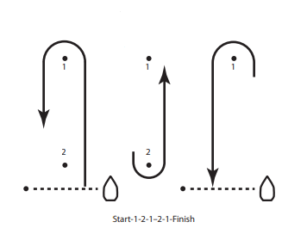
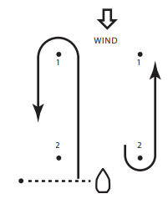

Start #2
HIGH PORTSMOUTH
Hobie 16, Dart, Hobie 18, Hobie 17

Start – 1 – 2 – 1 – Finish, where:

1 = Weather Mark
2 = Leeward Mark

Windward – Leeward Course
2 Laps with a Downwind Finish

Figure 3: High Portsmouth Course, Illustrated

